**PRESS RELEASE**

**IHCL PARTNERS WITH ANITA MENDIRATTA FOUNDATION TO EMPOWER WOMEN IN ANDHRA PRADESH**

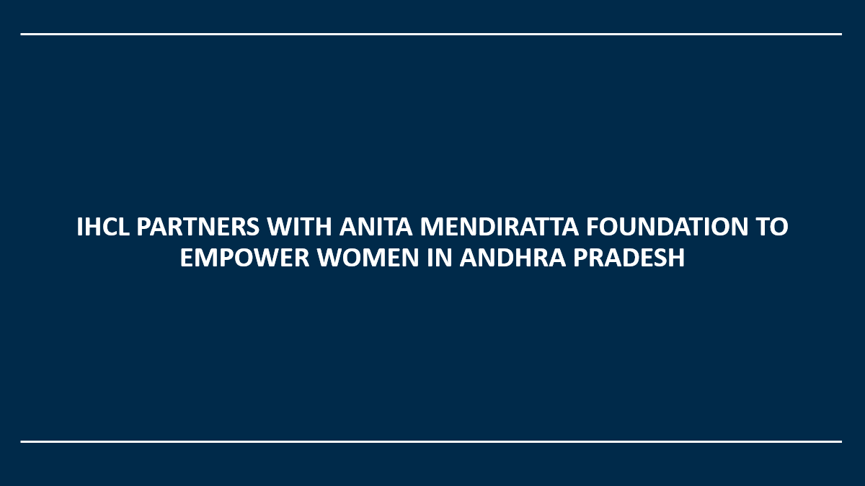

**MUMBAI, OCTOBER 25, 2024:** [**Indian Hotels Company Limited (IHCL)**](https://www.ihcltata.com/), South Asia’s largest hospitality company, announced a strategic partnership with [**Anita Mendiratta Foundation (AMF)**](http://www.anitamendirattafoundation.org) to provide funding for the **Empower-Her Andhra Pradesh Sewing Project**. The partnership aims to uplift women from over **18 villages** in the state by equipping them with sewing skills to achieve sustainable income, independence, and empowerment.

Speaking on the occasion, **Mr. Gaurav Pokhariyal, Executive Vice President – Human Resources, IHCL** said, “The Empower-Her Andhra Pradesh Sewing Project embodies IHCL’s principles of **Paathya** by driving meaningful community impact and fostering long-term socio-economic growth. This partnership reflects our belief that empowering women is key to building stronger communities. Through sustainable skill development, we aim to create a lasting change that uplifts individuals and promotes a more inclusive future.”

The Empower-Her Andhra Pradesh Sewing Project addresses the pressing need for skill development initiatives focused on women in rural and semi-urban areas where employment opportunities are limited. The initiative’s focus on self-employment through sewing will enable women to generate a steady income and create sustainable livelihoods.

**Ms. Anita Mendiratta, Founder & Chair, The Anita Mendiratta Foundation**, added, “Empowering women through vocational training creates a ripple effect that strengthens families, communities, and economies. This initiative provides essential skills while celebrating the rich cultural heritage of Andhra Pradesh, paving the way for sustainable growth.To bring it to life and lives with IHCL is an immense joy and honour for my Foundation”

The Empower-Her Andhra Pradesh Sewing Project will train over 50 women in the villages surrounding **Sattenapalle, Tiruvuru**, and **Hanuman Junction**, providing them with sewing skills to gain sustainable income, empowerment, and independence. This project will unlock new opportunities for women and set a foundation for long-term economic and social development in the region. Implementation of the project will occur through AMF’s trusted project activation partners **Adventure Aid** and **Mercy And Grace Charitable Trust.**

**About The Indian Hotels Company Limited**

**The Indian Hotels Company Limited (IHCL)**and its subsidiaries bring together a group of brands and businesses that offer a fusion of warm Indian hospitality and world-class service. These include **Taj –**the iconic brand for the most discerning travellers and ranked as **World's Strongest Hotel Brand 2024** and **India’s Strongest Brand 2024** as per Brand Finance; **SeleQtions**, a named collection of hotels; **Vivanta**, sophisticated upscale hotels; **Gateway**, full-service hotels designed to be your gateway to exceptional destinations and **Ginger**, which is revolutionising the lean luxe segment.

Incorporated by the founder of the Tata Group, Jamsetji Tata, the Company opened its first hotel - The Taj Mahal Palace, in Bombay in 1903. IHCL has a portfolio of **345**hotels including **115**under development globally across 4 continents, 13 countries and in over 130 locations. The Indian Hotels Company Limited (IHCL) is India’s largest hospitality company by market capitalization. It is listed on the BSE and NSE.

Please visit:[**IHCL**](http://www.ihcltata.com/)**;**[**Taj**](http://www.tajhotels.com/)**;**[**SeleQtions**](http://www.seleqtionshotels.com/)**;**[**Vivanta**](http://www.vivantahotels.com/)**;**[**Gateway**](https://www.gateway-hotels.com/en-in?sessionId=9afa29da-407d-4d6f-9d90-4b124247750c.d029b5ce-ce09-44e9-b0be-0f3f5101140b&jarvisId=f23854ee-5703-4a86-bb7a-fa455e799679&sessionId=21d491a0-f093-4559-af95-2be625a5a21a.d029b5ce-ce09-44e9-b0be-0f3f5101140b&jarvisId=f23854ee-5703-4a86-bb7a-fa455e799679)**;**[**Ginger**](http://www.gingerhotels.com/)

For media queries, please contact: [**malihah.faizi@ihcltata.com**](mailto:malihah.faizi@ihcltata.com)

**About The Anita Mendiratta Foundation (AMF)**

The Anita Mendiratta Foundation (AMF) - a UK Registered Charitable Organisation - focuses on sustaining the advancement of education and skills development - especially employable skills - in developing communities around the world, aiding persons regardless of sex, race, religion, or nationality.

Please visit: [**www.anitamendirattafoundation.org**](http://www.anitamendirattafoundation.org)